Havel, Jaroslav Joseph, Dr (based mainly on Roger Underwood (2006) “Old Growth Foresters. The lives and times of West Australian Foresters”)
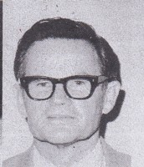
Arrived in Australia in 1948 (age 18) from Czechoslovakia. Worked for Millars Jarrahdale for 6 months, then forests Department gang at Gleneagle 1949-51. Then went to University and Australian Forestry School, from which he graduated in1954. Worked as a forester in Papua New Guinea. In the 1960s he returned to the Forests Department, as a research officer. Developed a vegetation classification system, as a basis for land management. Promoted to Superintendent and then Chief of Division Research. When CALM was formed in 1985, he was appointed Director of Research and Planning. PhD from Murdock University 2000. Retired in 1985.

